Edge banding
High quality edge sealing give the panels an exclusive look. The specific edge sealing options offer the best solution for every application.
The panels can be used both indoors and outdoors, nothing stands in the way.

Int-1 Edge banding in facing sheet material
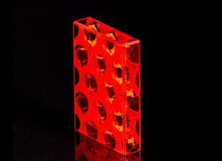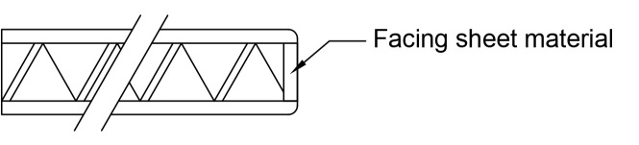
Edge banding in the best optical quality for indoor applications. A strip of facing sheet material is bonded between the inner surface of the facing sheeets.

Int-3 Edge banding silver 3D
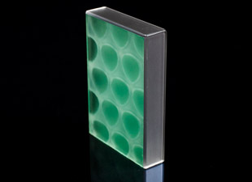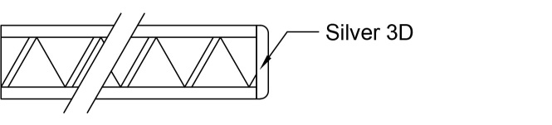
Edge banding for idoor applications, non transpartent edging material applied by machine. Other colours on request.

Ext-1 Acrylic edge sealing
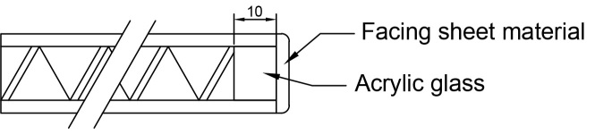
Edge banding in the best optical quality for indoor and outdoor applications. A 10 mm strip of acrylic material is bonded between the inner surface if the facing sheeets to which an overlapping strip of facing sheet material is applied.

Ext-2 Acrylic edge sealing
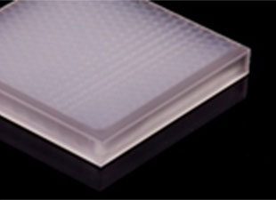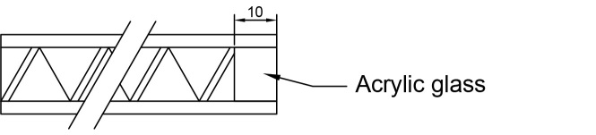
Edge banding in the best optical quality for indoor and outdoor applications. A 10 mm strip of acrylic material is bonded between the inner surface of the facing sheeets. Choice of colour to customers requirement.

Ext-3 Combined silicone edge sealing
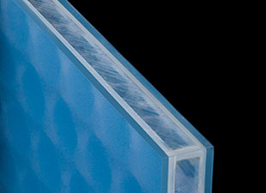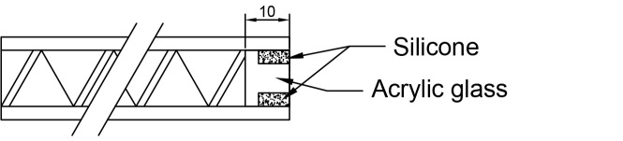
Waterproof edge sealing for external applications consiting of a combination of a grooved acrylic glass strip and a silicone filling; particularily applicable for thicker panels.

Ext-4 Silicone edge sealing
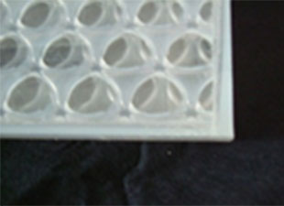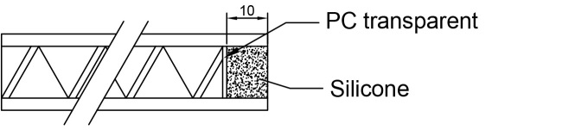
Waterproof transparent silicone edge sealing for external applications.

Custom options on request!

