System solutions
With our system solutions we present bespoke concepts for interior and external applications. Special profile systems offer room partitions, decorative walls, swing and sliding doors, shading systems and many other possibilities for requirements with a higher level of design.
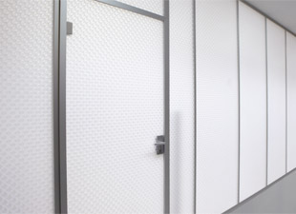

Wall systems
Complete wall systems, integrated doors and profile systems are delivered ready for assembly.
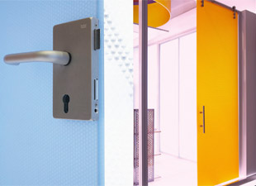

Door systems
Customized hinged & slinding doors together with the appropriate mounting systems.
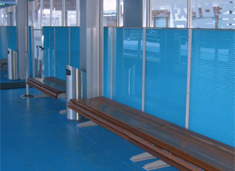

Partition walls
Temporary or permanent partition walls for applications such as exhibition booths, congresses, offices, foyers etc.
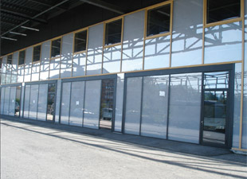

Facades
The weather-resistant panels from UV-resistant materials with outstanding thermal insulation values are at their best when illuminated from the rear or with sunlight.
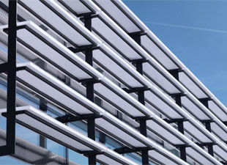

Shading systems
The weather-resistant panels from UV-resistant materials are providing a distinct look to a building’s exterior while providing shade and increased comfort.
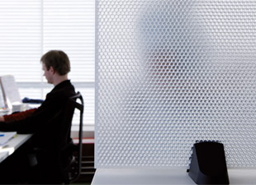

Acoustic systems
The specially developed acoustic panels for ceilings, walls and partitions are used to improve the room acoustics and sound absorption.

